**Assignment**

1. **Table

   Description automatically generated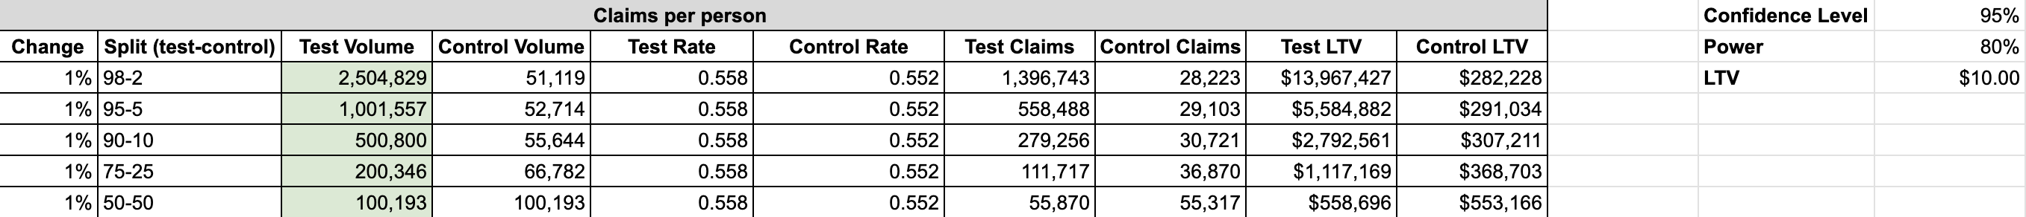Automate the python code to get a similar output as the tool for random split (example: 7-93, 22-78).**
2. **Automate the python code to generate the similar graph as shown below:**

